**Table of Contents**



**FPT International School**

--- o0o ---

**PROJECT REPORT**

**<Project Name>**

Batch: C1706L

Semester: 1

Group: 4

1. Student1029299 Nguyen Quoc Anh
2. Student1045002 Nguyen Thu Thao
3. Student1045006 Nguyen Ngoc Thuy

**Hanoi - 11/2017**

1. Problem Definition 3

i. Introduction 3

ii. Implementation Environment 3

User Stories 4

1.2 User type 1 (Example: Admin) 4

i. Story 1 4

ii. Story 2 4

iii. Story 3 4

iv. … 4

1.3 User type 2 (Example: Staff) 4

i. Story 1 4

ii. Story 2 4

iii. … 4

1.4 User type 3 (Example: Customer) 4

i. Story 1 4

ii. Story 2 4

iii. Story 3 4

iv. … 4

1.5 … 4

1.6 … 4

1.7 ... 4

1.8 ... 4

2. Database 5

2.1 DB Relationship Diagram 5

2.2 Table 1 (Example: Account) 5

2.3 Table 2 (Example: Caegory) 6

2.4 Table 3 (Example: Product) 6

2.5 … 6

2.6 … 6

2.7 ... 6

2.8 ... 6

3. UI\UX 7

3.1 GUI 1 (Example: Login Form) 7

3.2 GUI 2 (Example: Address Book Form) 7

3.3 GUI 3 8

3.4 … 8

3.5 … 9

3.6 … 9

3.7 ... 9

3.8 ... 9

3.9 ... 9

3.10 ... 9

3.11 ... 9

4. Summary 10

# Problem Definition

### Introduction

**Requirement Specification:**

The Web site is to be created based on the following requirements.

1. The Home Page should be created making use of Sections with a suitable logo, the header section can be added which will show images of various LED Lights.
2. The site must contain the links to navigate through various types of LED Lights.
3. Links of LED Lights can be categorized like (Bulbs, Spot Lights, Decoration Lights, Smart Lights etc.)
4. Specification and Pricing of Lights should be added along with the images.
5. Website should provide section for various brands offered in the store.
6. Gallery section should be added for viewing different images.
7. Feedback must be allowed to enter by the viewer
8. Site map, Gallery, about us, Queries link, Contact us link must be added. Address of the Company should be displayed using GeoLocation API (eg. GoogleMaps) and the email address which when clicked will invoke the local mail client from where they can send an email.
9. The complete description must be allowed to get download as pdf or doc file.
10. The advertise section with various facilities provided should be mentioned.

### Implementation Environment

* Platform
* Windows 10
* Language
* HTML 5
* CSS3
* Javascript
* JQuery
* Bootstrap 3
* Application
* Dreamweaver CS6
* Chrome
* FireFox

# User Stories

## Customer

### Log in

As a customer , i want login to the website

### Register

As a customer , i want register to the website

### Search by name

As a customer , i want search the products by their name

### View the description of each product

As a customer , i want contact to admin

# Follow chart

UI\UX

## GUI 1: login

## Image result for login flowchart

## GUI 2: Register

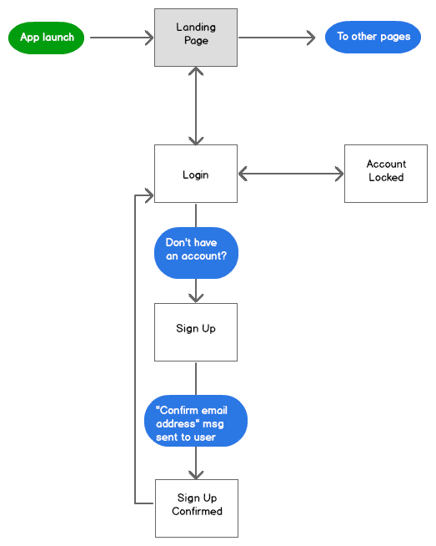

## GUI 3: search by names

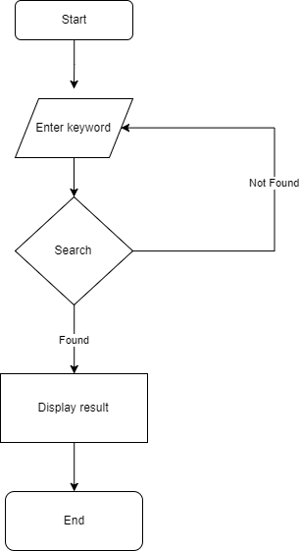

## GUI 4: View descripton of each product

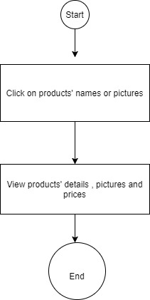

# Summary

* Homepage, header: Nguyen Ngoc Thuy
* Detail product web, find img and information of LEDs, logo design: Nguyen Thu Thao
* Login, register, search, footer: Nguyen Quoc Anh
* Brand, categories: all of team members.